Session 2026-2027

Vision:Dream of where you want. | Mission: Means to achieve Vision

Program Educational Objectives of the program (PEO): (broad statements that describe the professional and career accomplishments)
PEO1 | Preparation | P: Preparation | Pep-CL abbreviation  pronounce as Pep-si-lL easy to recall
PEO2 | Core Competence | E: Environment (Learning Environment) | Pep-CL abbreviation  pronounce as Pep-si-lL easy to recall
PEO3 | Breadth | P: Professionalism | Pep-CL abbreviation  pronounce as Pep-si-lL easy to recall
PEO4 | Professionalism | C: Core Competence | Pep-CL abbreviation  pronounce as Pep-si-lL easy to recall
PEO5 | Learning Environment | L: Breadth (Learning in diverse areas) | Pep-CL abbreviation  pronounce as Pep-si-lL easy to recall

Program Outcomes (PO): (statements that describe what a student should be able to do and know by the end of a program)
Keywords of POs:
Engineering knowledge,Problem analysis, Design/development of solutions,Conduct Investigations of Complex Problems, Engineering Tool Usage, The Engineer and The World,Ethics, Individual and Collaborative Team work,Communication, Project Management and Finance, Life-Long Learning

PSO Keywords: Cutting edge technologies, Research

“I am an engineer, and I know how to apply engineering knowledge to investigate, analyse and design solutions to complex problems using tools for entire world following all ethics in a collaborative way with proper management skills throughout my life.” to contribute to the development of cutting-edge technologies and Research.

Integrity: I will adhere to the Laboratory Code of Conduct and ethics in its entirety.

Name and Signature of Student and Date
(Signature and Date in Handwritten)

Session | 2026-27 (ODD) |  | Course Name | Web Technology Lab
Semester | 3 |  | Course Code | 23CT1301
Roll No | 65 |  | Name of Student | Shubham Dnyaneshwar Umredkar
Practical Number |  | 6
Course Outcome |  | - Understand various internet technologies.  - Design the web pages using HTML and CSS.  - Implement the XML technology to store the data.  - Develop the interactive web pages using JavaScript.
Aim |  | JavaScript — Arrays, Objects &amp; Higher-Order Functions
Problem Definition |  | Model shopping-cart products as an array of objects and  implement add-to-cart, remove-item, and total-price calculation using map(), filter(), and reduce().
Theory  (100 words) |  | A Shopping Cart is a system used in e-commerce applications to store products selected by a user. In JavaScript, products can be represented using an array of objects, where each object contains details such as product ID, name, and price.  In this program, the following JavaScript array methods are used:  map() – Used to create and display a list of cart items.  filter() – Used to remove a selected item from the cart.  reduce() – Used to calculate the total price of all items in the cart.  find() – Used to find a product using its ID.  The program allows the user to add products to the cart, remove products, and calculate the total price.
Procedure and Execution  (100 Words) |  | Step for Implementation:  - Create an array named products containing product objects.  - Create an empty cart array to store selected products.  - Display all available products on the HTML page.  - Create an addToCart() function to add a product to the cart.  - Use find() to find the selected product using its ID.  - Create a displayCart() function to display cart items.  - Use map() to generate the list of cart items.  - Create a removeItem() function to remove an item.  - Use filter() to keep all items except the selected item.  - Use reduce() to calculate the total price.  - Display the calculated total price on the webpage.
Code:
html:
<!DOCTYPE html>
<html lang="en">
<head>
<meta charset="UTF-8">
<meta name="viewport" content="width=device-width, initial-scale=1.0">
<title>Shopping Cart</title>
</head>

<body>

<h1>Shopping Cart</h1>

<h2>Products</h2>

<div id="productList"></div>

<h2>Your Cart</h2>

<div id="cartList"></div>

<h3>Total Price: ₹<span id="totalPrice">0</span></h3>

<script src="Practicle_6.js"></script>

</body>
</html>

javascript:
let products = [
{
id: 1,
name: "Laptop",
price: 50000
},
{
id: 2,
name: "Mouse",
price: 800
},
{
id: 3,
name: "Keyboard",
price: 1500
},
{
id: 4,
name: "Headphones",
price: 2000
}
];

let cart = [];

function displayProducts() {
let productList = document.getElementById("productList");

productList.innerHTML = "";

products.forEach(function(product) {

productList.innerHTML += `
<p>
${product.name} - ₹${product.price}
<button onclick="addToCart(${product.id})">
Add to Cart
</button>
</p>
`;
});
}

function addToCart(id) {

let product = products.find(function(item) {
return item.id === id;
});

if (product) {
cart.push(product);
displayCart();
}
}

function removeItem(id) {

cart = cart.filter(function(item) {
return item.id !== id;
});

displayCart();
}

function displayCart() {

let cartList = document.getElementById("cartList");

if (cart.length === 0) {

cartList.innerHTML = "<p>Cart is empty</p>";

} else {

let items = cart.map(function(item) {

return `
<p>
${item.name} - ₹${item.price}
<button onclick="removeItem(${item.id})">
Remove
</button>
</p>
`;
});

cartList.innerHTML = items.join("");
}

let total = cart.reduce(function(sum, item) {
return sum + item.price;
}, 0);

document.getElementById("totalPrice").textContent = total;
}

displayProducts();
displayCart();

Output:
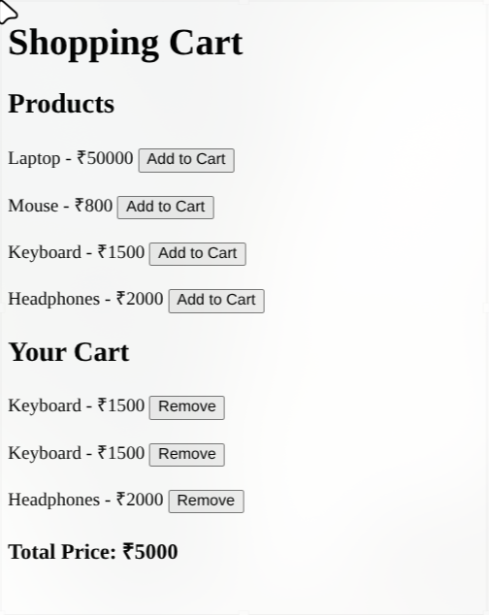
Output Analysis |  | The output of the program displays the available products along with an “Add to Cart” button. When a product is added, it appears in the shopping cart with its name and price. The total price is calculated automatically using the reduce() method. When an item is removed, the filter() method updates the cart and the total price is recalculated. Thus, the output demonstrates the working of add, remove, display, and total-price calculation operations.
Link of student Github profile where lab assignment has been uploaded |  | https://github.com/shubham07-codes/Web-Technology-Lab
Conclusion |  | The shopping cart system was successfully implemented using HTML and JavaScript. The program demonstrates how arrays of objects can be managed using JavaScript's map(), filter(), and reduce() methods. It supports adding and removing products and dynamically calculates the total price of the cart.
Plag Report (Similarity index < 12%)
Date |  | 29/09/26

